Website Specifications

Project overview
A Real Estate website that prioritizes customer preferences in housing and integrates them modern and traditional architecture. It also bridges societal housing gaps by providing a platform for non-profit housing company agents to connect with low-income individuals.

Objectives
The inauguration of a real estate website that aims at:
- Displaying trends in the housing market in the user’s interest
- Providing housing companies with a platform to connect with potential customers
- Acting as a common ground between landlords and customers that aren’t looking for permanent housing
- Addressing the intricacies of the house purchasing/rental process that exclude most people
- Lure in potential buyers and sellers through property inquiries, newsletters and mass media ads to lead generation
- Showcase property with the provision of detailed listings with photos and videos to surge buyer confidence
- Maintain client relationships through tools aimed at chat support and scheduling

Business goals in relation to real estate
A set of goals the business veers towards achieving in relation to real estate include:
- Website assumes the role of a 24/7 sales platform, widening coverage beyond offices to increase sales and revenue.
- Improve efficiency through automated listings, inquiries and updates to reduce operational costs
- Market expansion by including online presence to reach not only local target audience, but also national and international buyers.
- Retain competitiveness as per (Zillow premier agent) “A real estate business allows you to remain abreast with market trends and ahead of the competition.”
- Intrigue investors with a well-structured site of professionalism, which plays a pivotal role in attracting investors and partners. As said by Venngage.

To support our objective and goals we have adopted strategic facts from well-established real estate businesses
- SMART Goals: As emphasized by FasterCapital, setting Specific, measurable, Achievable, Relevant and Time-bound goals for estate marketing, ensuring clarity and accountability should be necessitated.
- Performance Tracking: Zillow stresses the importance of “fluidity” in websites and business plans, which should be regularly updated to reflect market changes

Target Audience for a real estate website
- Home Buyers
Demographics
- Age group: 23-55
- Income range: middle to upper-middle income brackets
- Motivations: first home purchase, relocation for work or personal matters, upgrading to larger properties for family
- Life stage: newlyweds, young professionals, growing families, relocators
Technical aptitude
- Comfortable using search engines and mobile apps
- Expect property filters, intuitive interfaces and map-based searches
- Familiar with online chat support and digital forms
- Value high-quality photos, videos and transparent information
- Home Renters
Demographics
- Age group: 18-33
- Income range: lower to middle income brackets
- Motivations: proximity to school or work, affordable housing
- Life stage: Students, temporary workers, early-career professionals
Technical Aptitude
- Heightened digital literacy
- Heavy smartphone usage for browsing
- Prefer time efficient page loading, quick inquiry forms and real time availability
- Comfortable with online scheduling for viewing

- Real Estate agents&Agencies
Demographics
- Age group: 25-50
- Income range: Upper middle to high income brackets
- professional role: brokers, sales agents, property managers
Technical Aptitudes
- Adequately tech savvy
- Value automation: Alerts, email updates and appointment scheduling functionalities
- Prefer convenient management of websites from smartphones and personal computers

- Sellers (landowners or homeowners)
Demographics
- Age Group: 35-70
- Income range: Dependent on property type
- Motivations: Downsizing, Upgrading, asset liquidation, relocation
Technical Aptitude
- Basic to advanced tech skills
- Value chat boxes, emails or clear instructions
- Expect clear steps for uploading photos and easy listing tools

Type Of Website And Content That Will Be Designed For Users
  - Website Type
Real estate portal, open to users of different capacities. Buyers, sellers, renters, agents, and investors are provided with a common property portal with exceptional search capabilities and user focused experience.
  - Content per audience
1)Home Buyers
- Content type: Includes property listings and a buyer hub
- Content format:
- House physical properties
- Neighborhood details
- Buying guides
- Mortgage and price details
- Book a viewing, save properties, set alerts

2)Renters
- Content type: rental marketplace
- Content format:
- Real time availability and term filters
- Proximity search and view booked appointments
- Rental application forms
- Apply online, schedule viewings
3)Sellers or Landlords
- Content type: owner hub and selling mini site
- Content format:
- Valuation tool, pricing guide
- Marketing plan (photography, paid ads)
- Property performance dashboard (views, inquiries)
- List property, place valuations

4)Real estate agents & Agencies
- Content type: agent hub
- Content format:
- Agent profiles, reviews and availability
- View analytics, listing management
- Recruit agents, improve response time

Information Design & Taxonomy
  - Information Architecture
1) Home
- Featured properties
- Search bar with filters (location, price, type, bedrooms)
- Quick user selection (buy/rent/sell/agent)
- Featured agent(s)
- Call-to-action (CTA) panel (list your property, sell with us)
Navigation flow:
- Home→search→results→details
- Home→featured property→property details
- Home→user selection
- Home→agent→directory→profile→contact
- Home→sellers→properties
2)Buy
- Search filters (location, price, property type, bedrooms)
- Grid view
- Saved properties(logged in)
- Featured listings
Property detail page:
- Photos or videos
- Prices
- Property description
- Viewing booking form
- Similar properties
Subsections:
- Houses for sale
- Apartments for sale
- Luxury properties
- Plots and land
Navigation flows:
- Buy → search → results → property details
- Buy → property → contact agent
3) Rent
- Search filters (lease-term, furnished, location)
- Grid view
Property Details:
- Photos or videos
- Deposit
- Lease terms
- Pet policy
Subsections
- Short term rentals
- Student accommodation
- Houses for rent
- Apartments for rent

Navigation flows:
- Rent →search → results →property → book viewing
4)Sell
- Benefits of listing
- Selling guide
- Property valuation form
- Agent matching tool
Subsections:
- Sell your home → Agent contact
- “Is my home worth the money?” → valuation form
Navigation flows:
- Sell → valuation → agent
- Sell → Tips
5)Agents
Agent Directory:
- Search by name or location
- Filter by specialization
- Ratings
Agent Profile:
- Contact form
- Current listings
- Agent bio
- Achievements
Navigation flows:
- Agents →Agent profile →Property listings
6) Developments
- New estates & Townhouses
Detail page:
- Pricing tiers
- Availability
Navigation flows:
- Developments→Project→download brochure
7) Commercial
- Office space
- Retail space
- Warehouses
Navigation flows:
Commercial →Search→Listing→Agent
8) About Us
- Company overview
- Mission & values
- Team members
- Careers
9) Contact
- Contact form
- Phone & email
- Social media
10) My Account
For registering /logging in in buyers, sellers, landlords,renters
- Sign up/log in
Buyer dashboard:
- Saved properties
- Recently viewed properties
- Account settings
- Appointments & viewings
- Chat box
Seller & landlord dashboard:
- Mange listings
- Add listing
- Documents and agreements

Renter dashboard:
- Lease documents
- Maintenance requests
  - Footer Navigation
- Terms & conditions
- Privacy policy
- Contact
- Social media links
- Cookie policy

Visual sitemap
Home
├── Buy
│ ├── Houses for Sale
│ ├── Apartments for Sale
│ ├── Plots
│ └── Property Details
│
├── Rent
│ ├── Houses for Rent
│ ├── Apartments for Rent
│ └── Property Details
│
├── Sell
│ ├── Valuation
│ └── Selling Guide
│
├── Developments
│ └── Development Details
│
├── Commercial
│ └── Commercial Property Details
│
├── Agents
│ └── Agent Profile
│
├── About Us
├── Contact
└── My Account
├── Buyer Dashboard
├── Login / Register
├── Seller Dashboard
└── Renter Dashboard

Page Template Design
The website uses a layout that displays:
- The logo and name at the top left
- Navigation plane that remains visible while scrolling
- Content occupying white space (text and images)
- Footer at the bottom with quick links and contact

Homepage wireframe
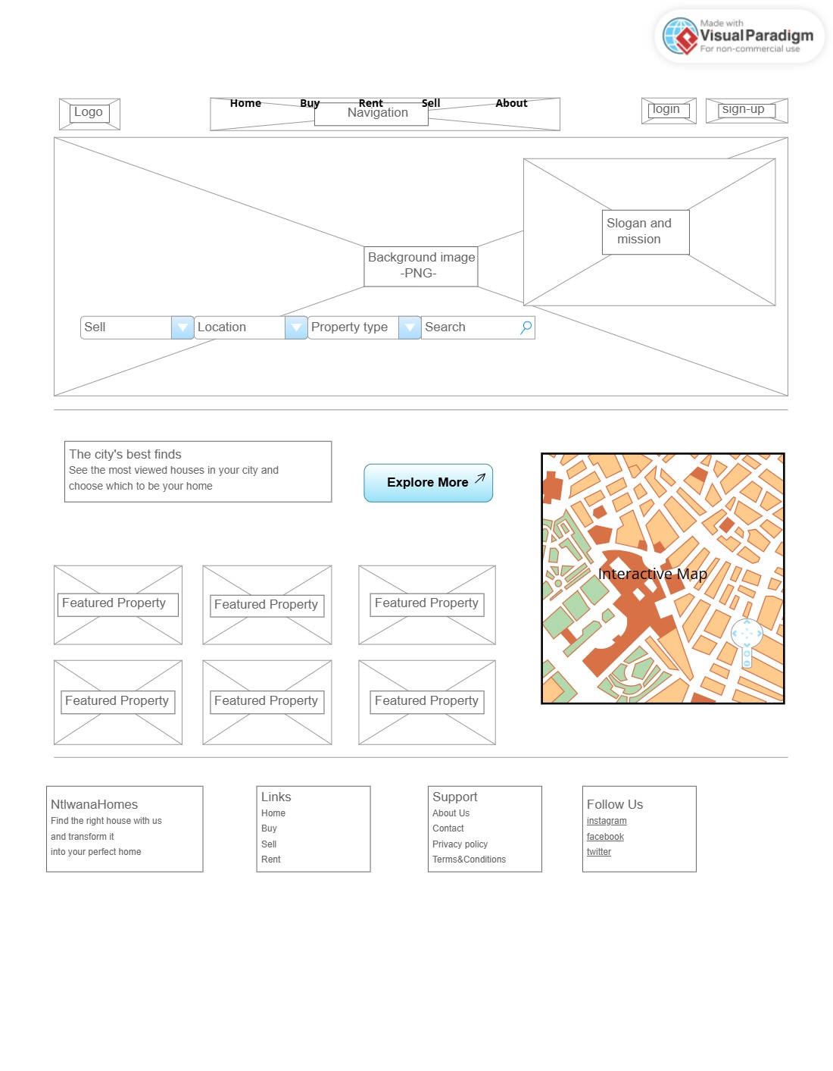
Sell Page wireframe
